Date:07/09/26

Aim:

7a)Configuration of HyperV on Windows of VMs

To configure Hyper-V on Windows for creating and managing virtual machines(VMs),

Enabling efficient virtualization and resource utilization.

Steps:

- Click Turn Windows features on or off.
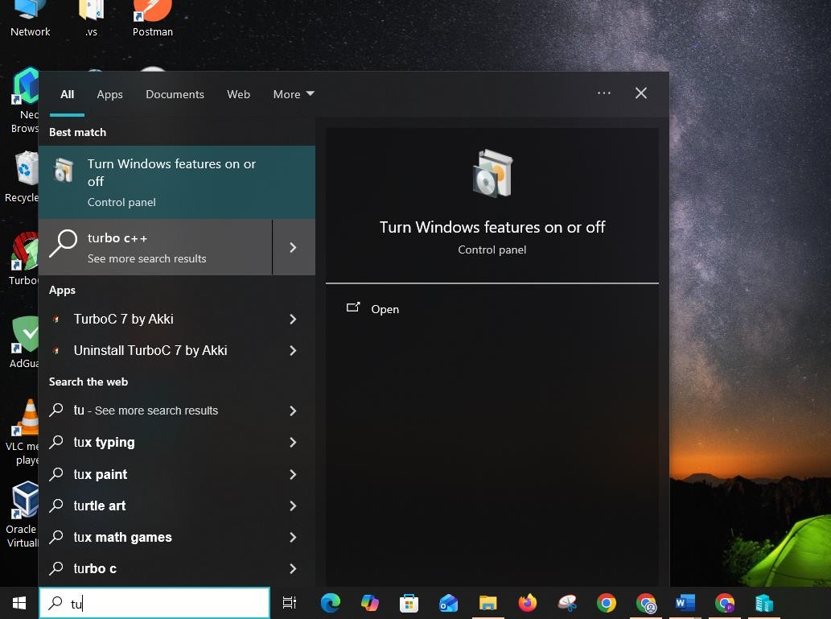

- Find Hyper-V select all hyper-V and restart
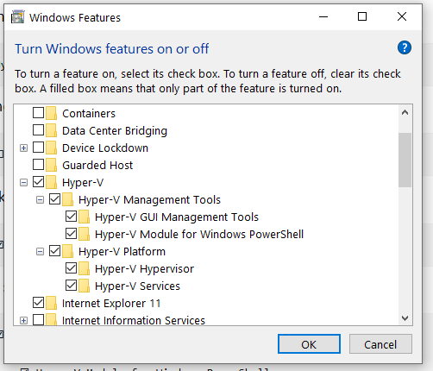
- After your PC restarts Press the Windowskey and search : Hyper-V Manager
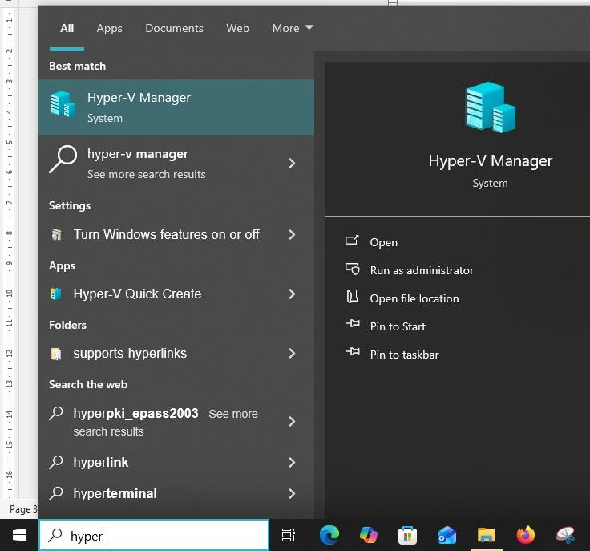

- The hypervisor manager will open
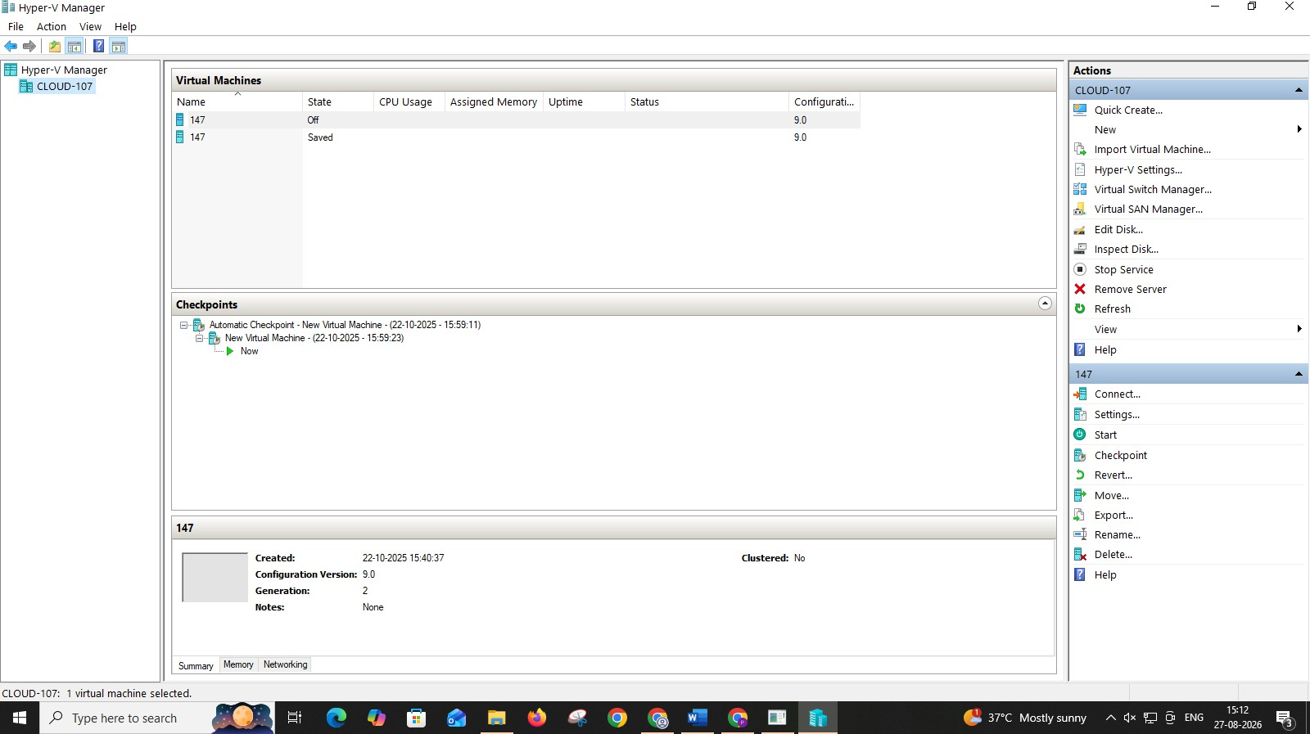

RESULT:

Thus the configuration Hyper-V on Windows for creating and managing virtual machines(VMs),enabling efficient virtualization and resource utilization has been executed successfully.

7b) Creation of VM ,Powershell commands ,Management

Aim:

To create and manage VirtualMachines(VMs) using Hyper-V,including PowerShell commands for automation and efficient administration.

Procedure:

(Vm installation without powershell)

- openTools->hypervmanager->right click on server and click create new vm
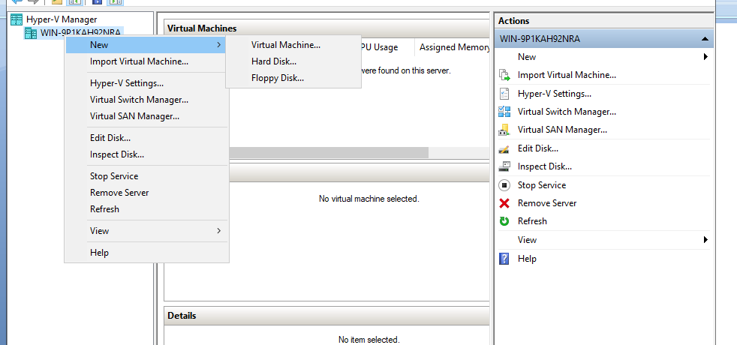
- Specify name and location click next.

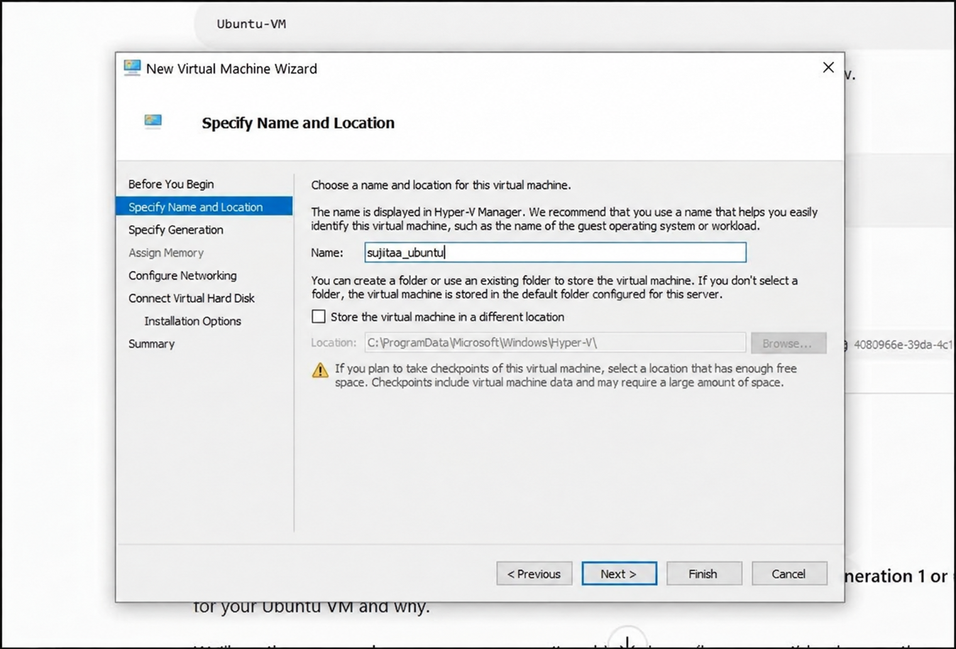

3.Now Specify generation 2
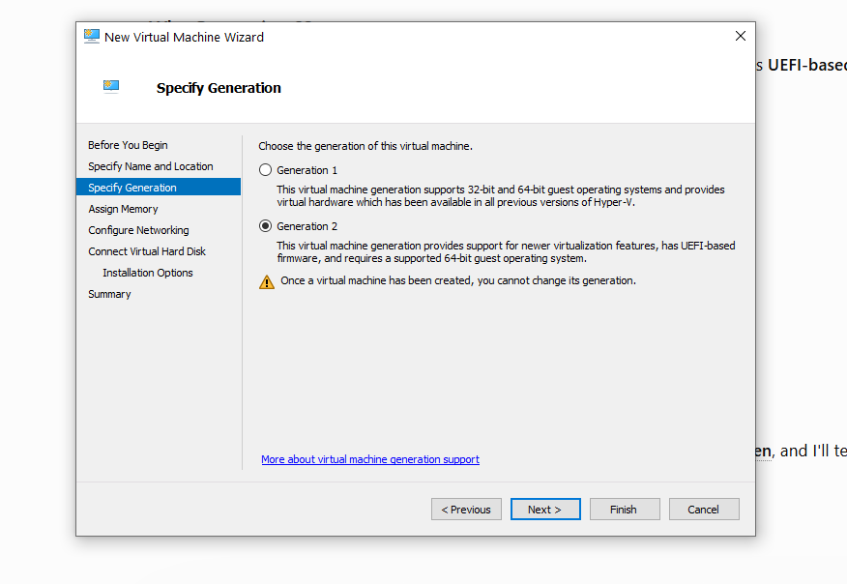

- Assign the memory for the vm (for safety give as 2gb)
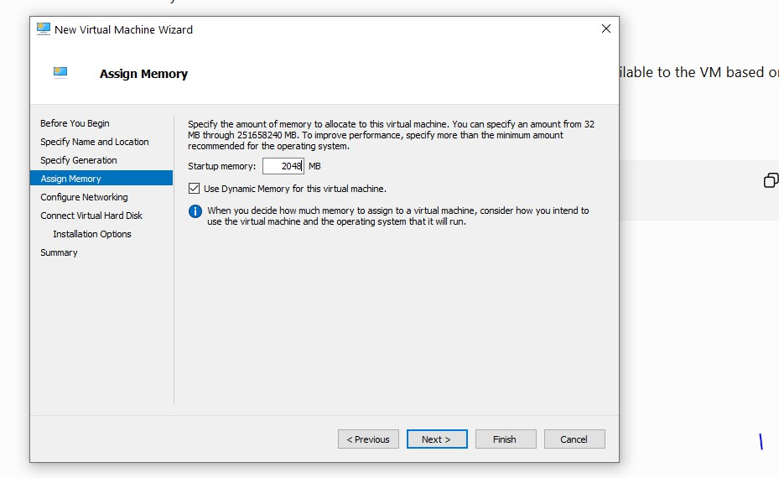

- Configure the network click on Default Switch
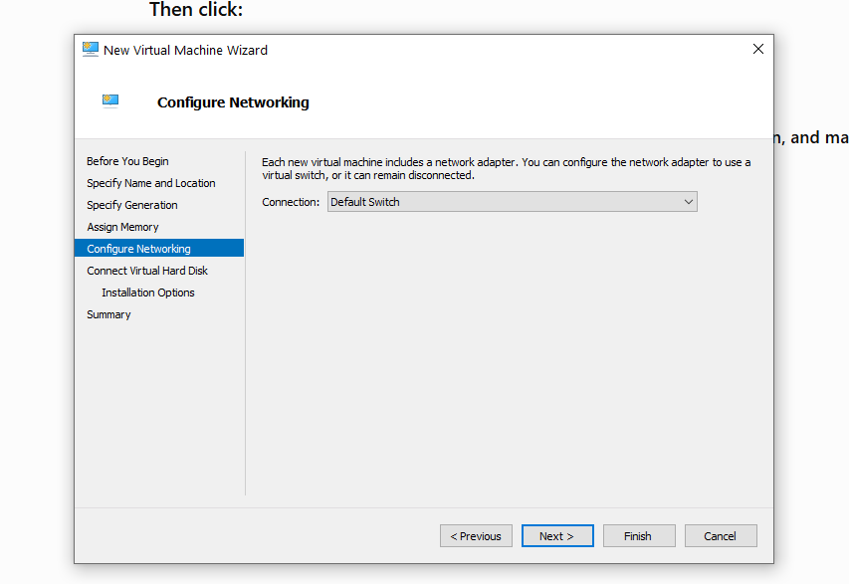

- Connect virtual hard disk click next

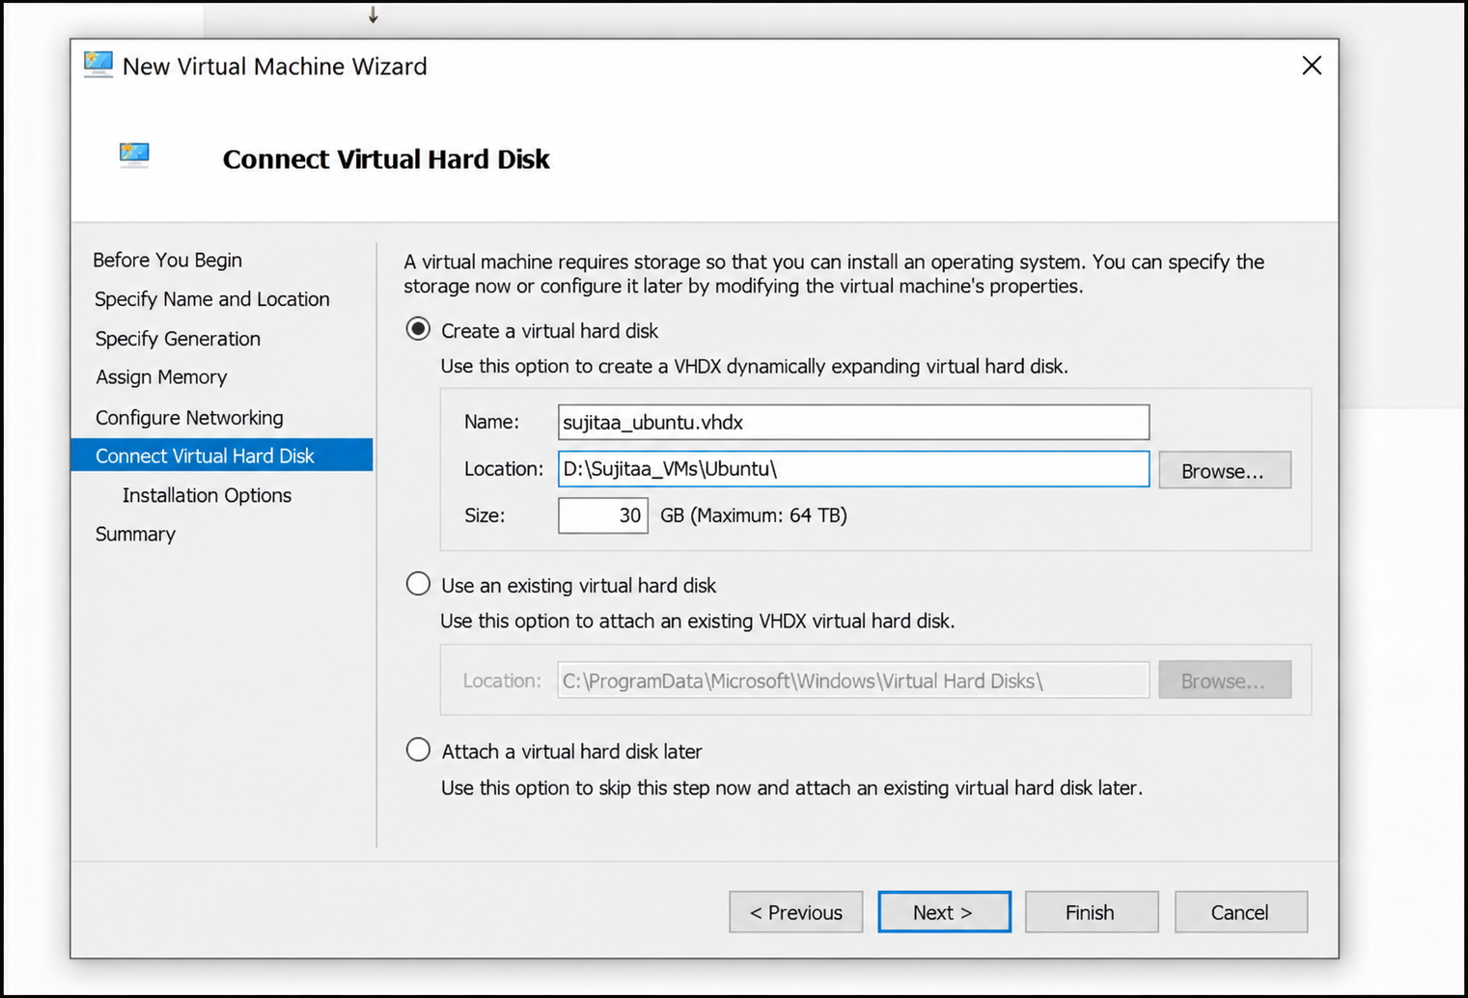

- Import the iso file which os need to install on the vm (here ubuntu)
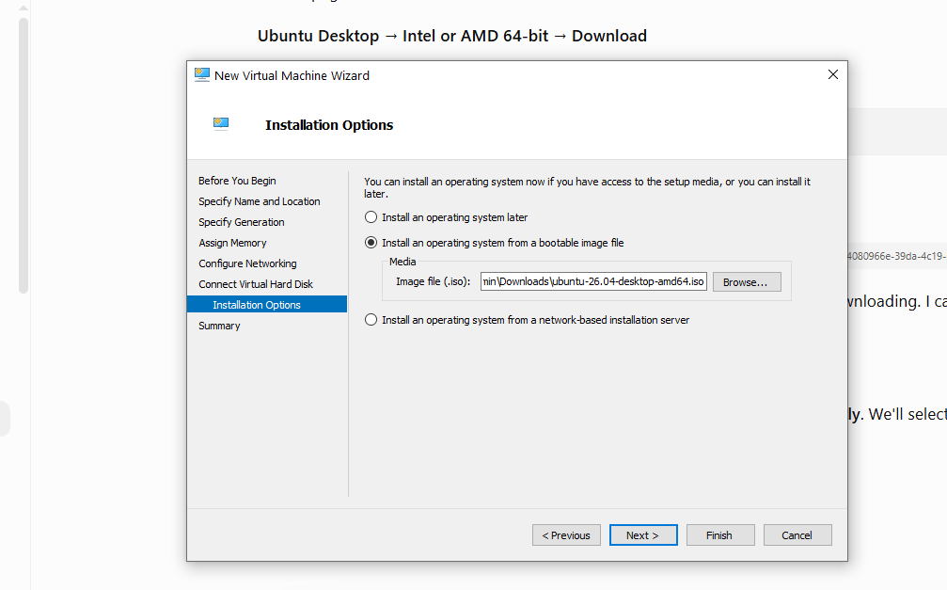
- Click finish

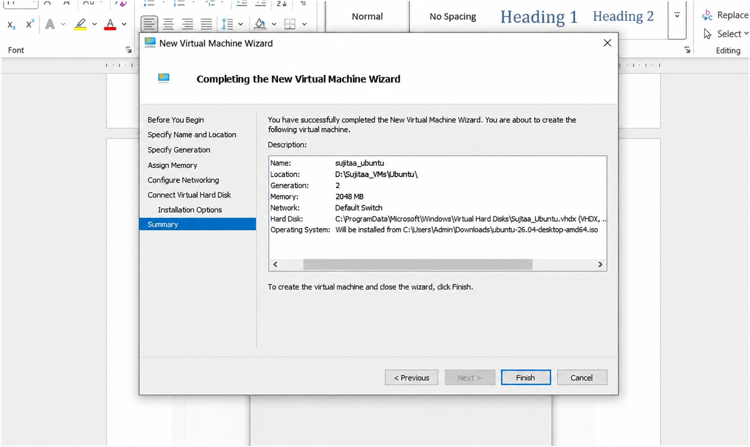

- Change the Security setting- Change Template to Microsoft UEFI
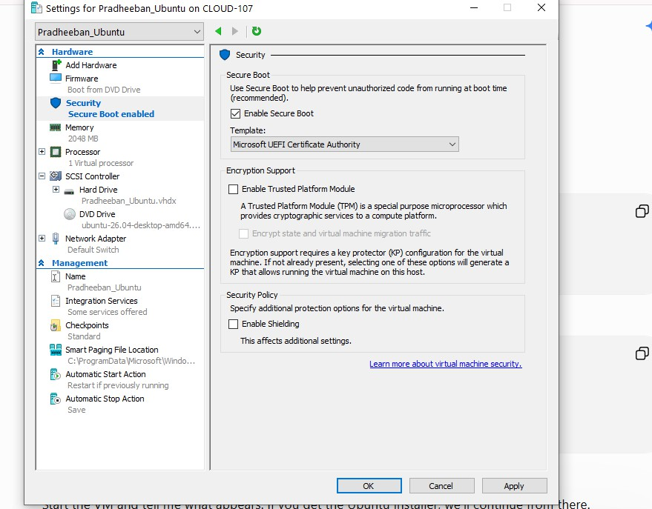

- We can start the vm in hyper-V manager by using connect option in the right panel after starting the VM
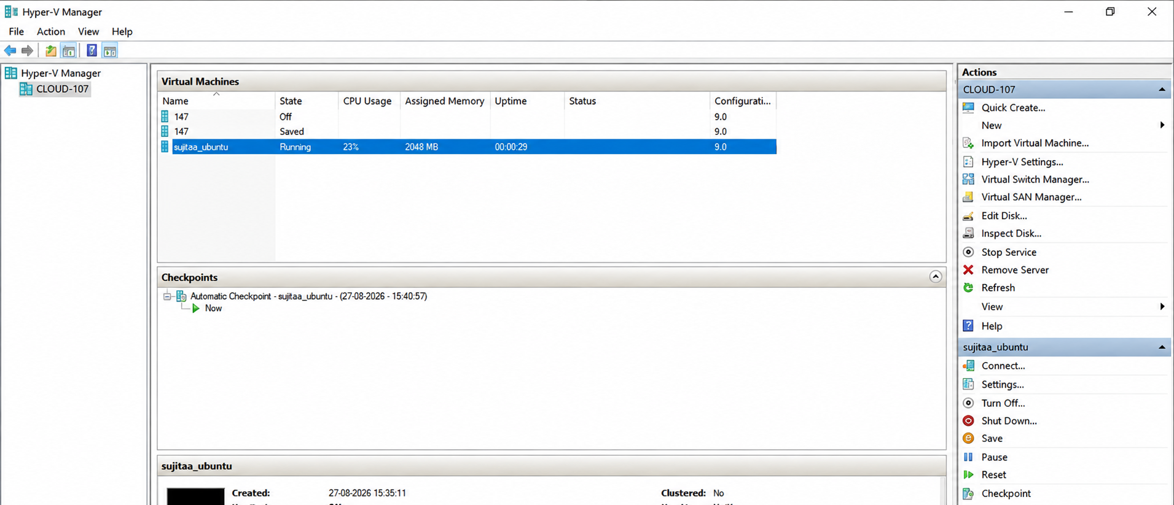

- Once the VM starts it ask for setup and follow the steps in the screenshots:
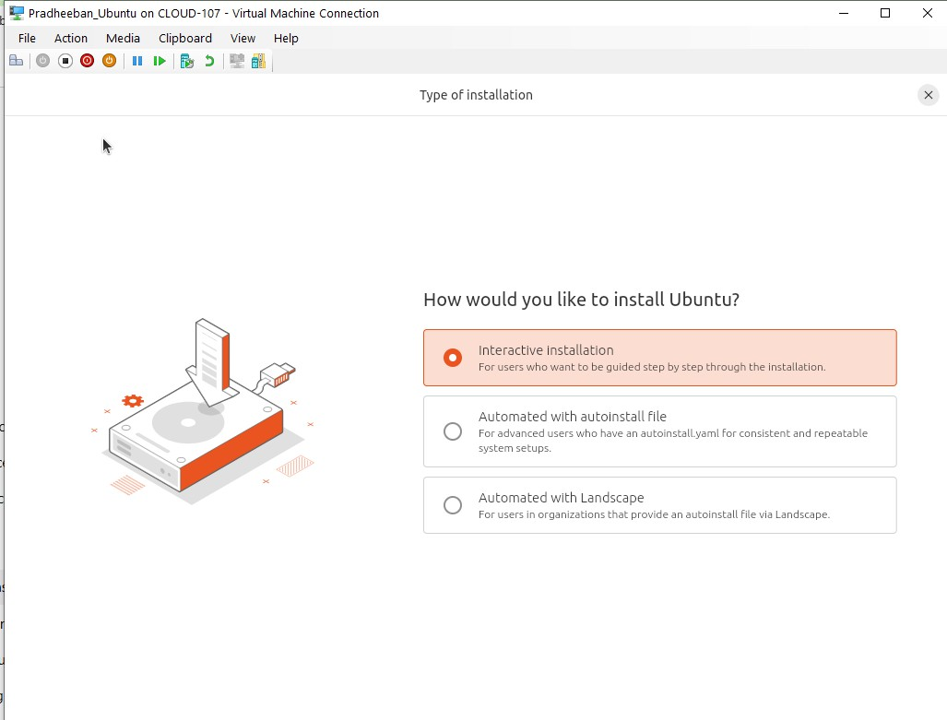
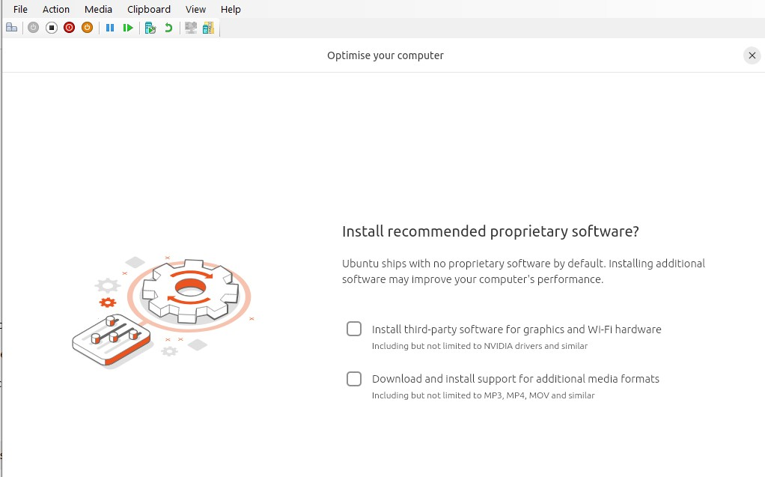

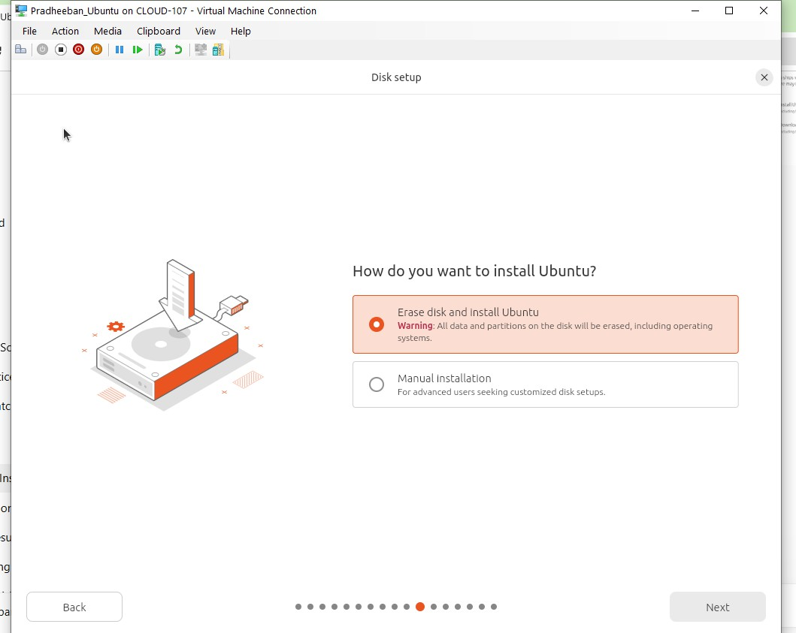

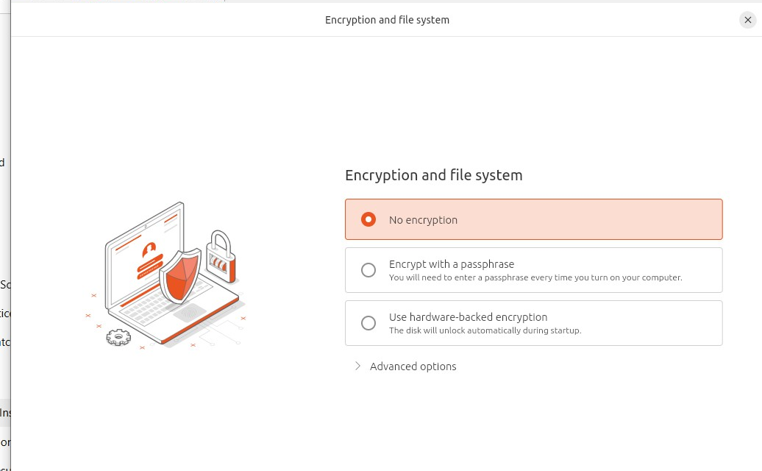

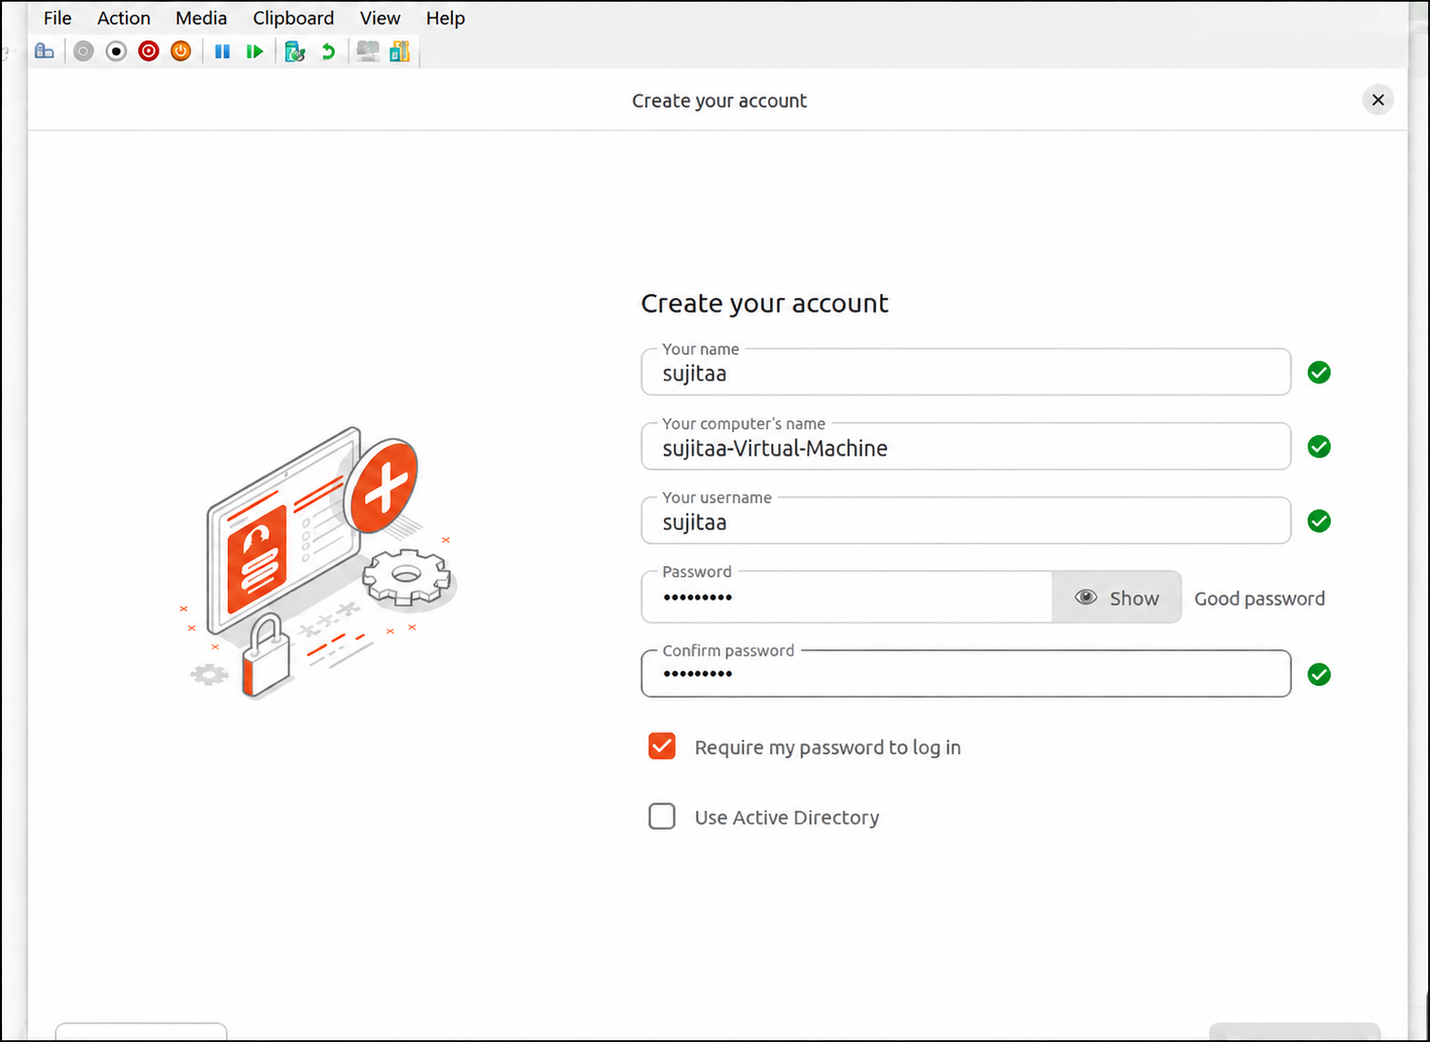

After finishing all the step sit will start to install and it will ask to restart after restarting the ubuntu screen will appear

Vm installation using Powershell
Procedure:

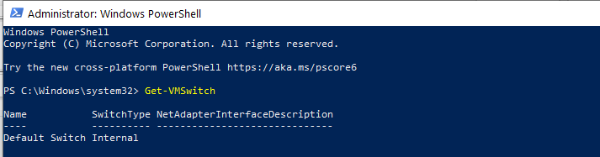
Get-VM Switch

- Create vm with name and spacing with virtual hard disk creation

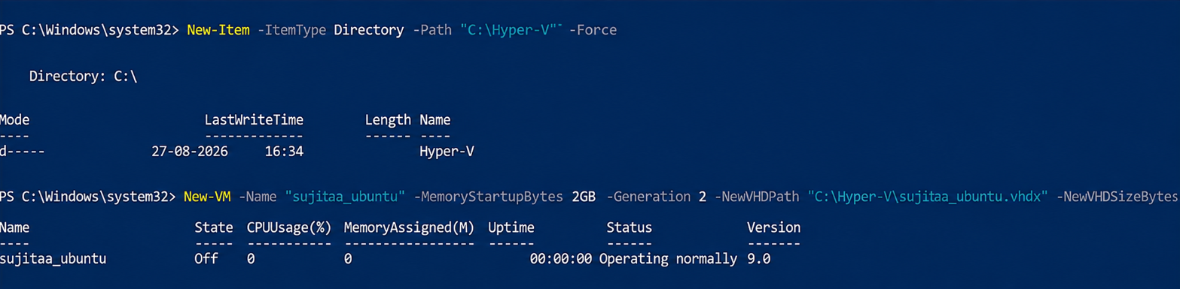

- Asssignvirtualswitchtothevmgivetheswitchaswealreadygotinthegetswitch command
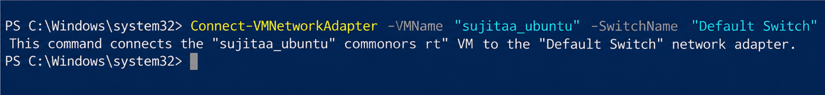

Powershell commands

1)To see the status of VM and Stop the VM

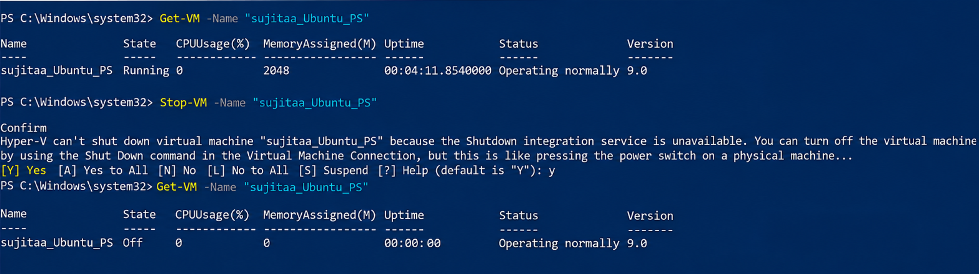

Migration :
Right click the vm and click move and follow the steps.
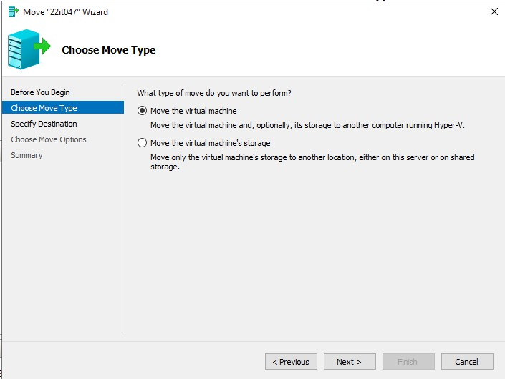
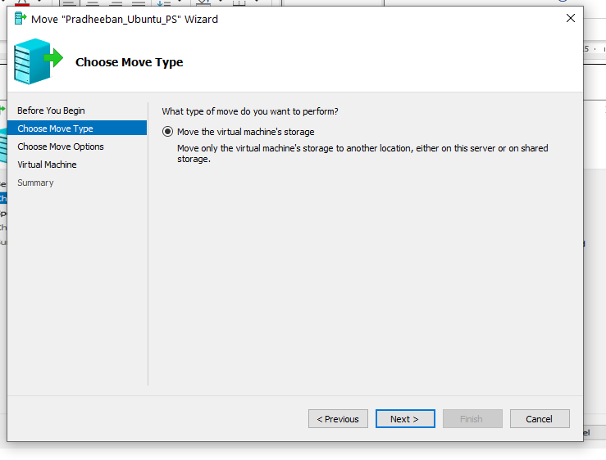

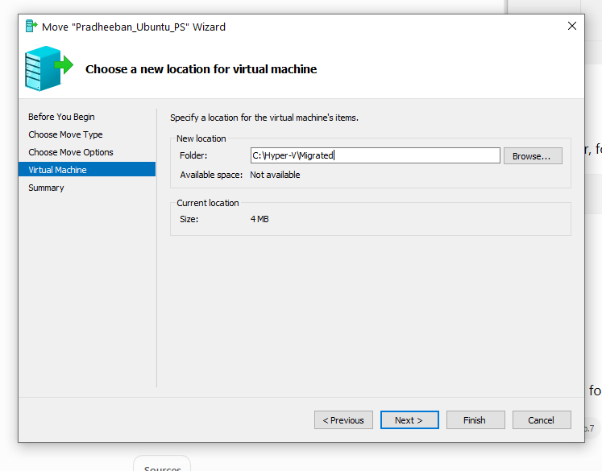
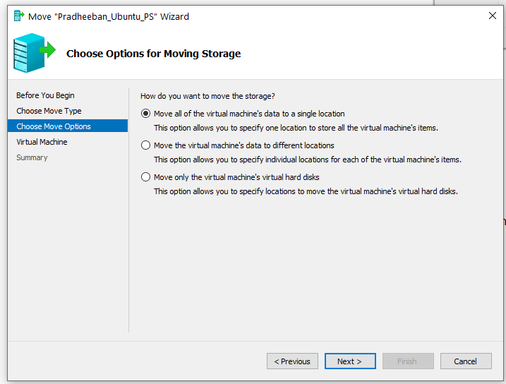

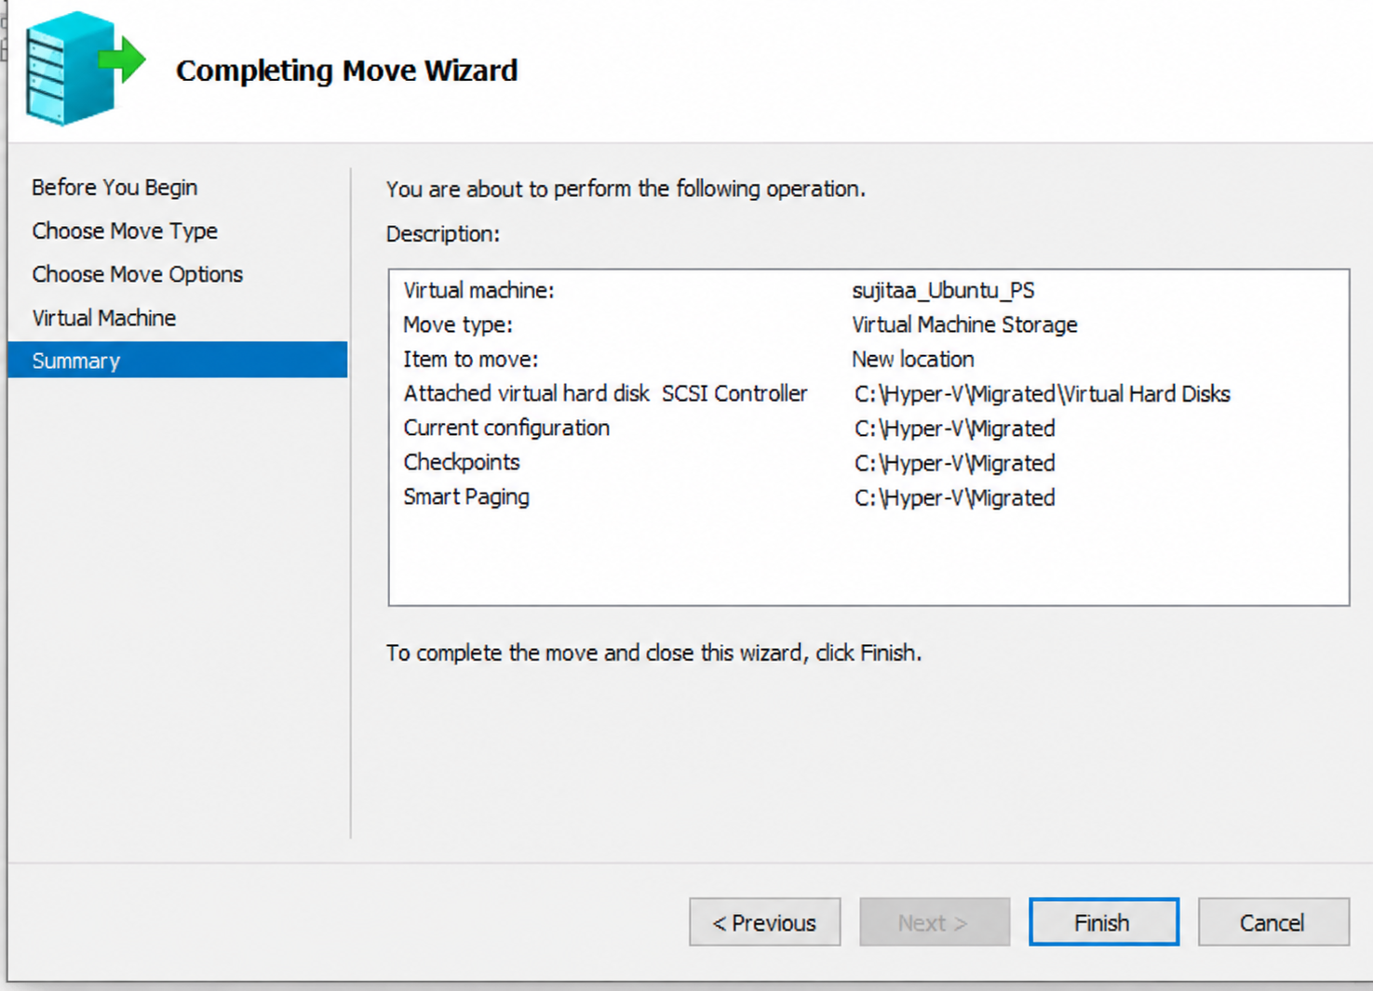

TheVM is Succesfully moved

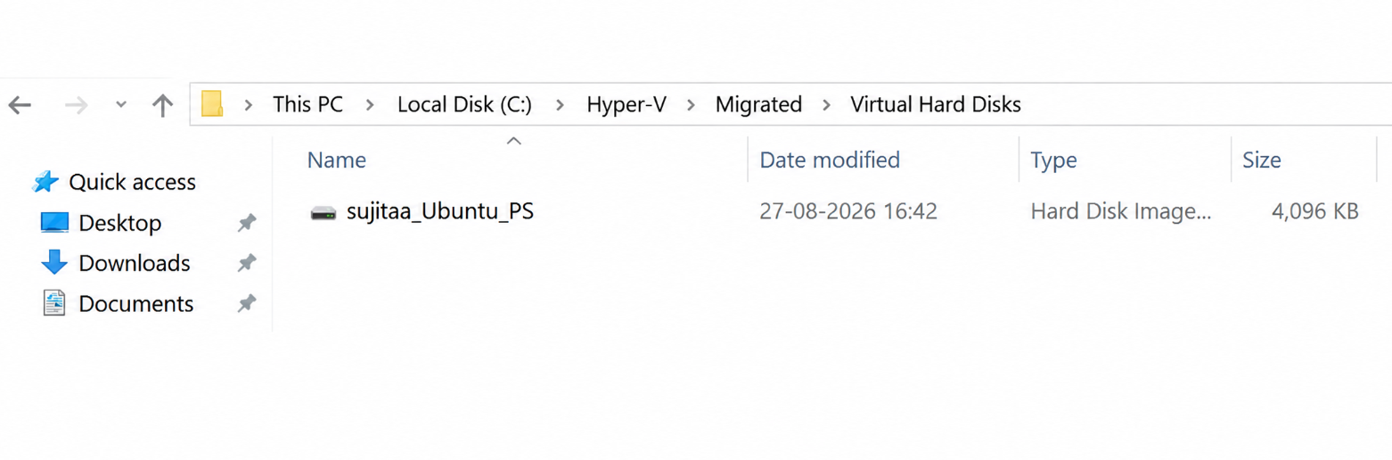

Result:

Thus the creation and manage VirtualMachines(VMs) using Hyper-V, including PowerShell commands for automation and efficient administration has been executed successfully.

